##### Saddle Bag with Strap

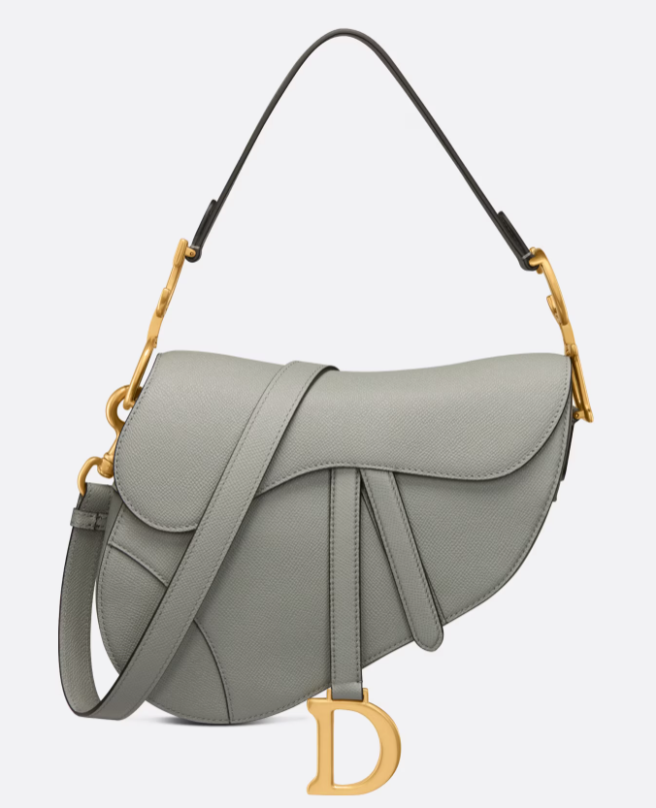  
The Saddle Bag with Strap is a popular and iconic design from the luxury fashion house Dior. It's a modern take on the classic equestrian-inspired saddlebag, featuring a distinctive curved silhouette and often adorned with the brand's signature "D" charm.

This bag typically comes with a detachable and adjustable shoulder strap, allowing for versatile wear as a crossbody or shoulder bag. It's crafted from high-quality materials such as leather or canvas and may feature intricate stitching and hardware details, reflecting Dior's attention to detail and craftsmanship.

If you're interested in purchasing a Saddle Bag with Strap, you can explore Dior's official website or visit their boutique stores to see the latest offerings. Dior offers this bag in various sizes, colors, and materials, so you can choose the option that best suits your style preferences. Additionally, you can also check with reputable luxury retailers or online platforms specializing in designer handbags to see if they have the Saddle Bag with Strap available for purchase.